Rhombidodecacron

Definition
# Source: AI Source: Provided by: [Data Path: Persons Table -> ID Column: 1, Name_En Column: Motasem Essam] -> From: [ChatGPT] on [7/25/2026]
The Rhombidodecacron is a nonconvex, isohedral star polyhedron composed of 60 intersecting quadrilateral faces called antiparallelograms (crossed quadrilaterals).
It has 120 edges and 42 vertices. It is the dual polyhedron of the Great Rhombidodecahedron, a nonconvex uniform star polyhedron.
The Rhombidodecacron is also known as the Great Dipteral Ditriacontahedron.

Geometric Structure
# Source: AI Source: Provided by: [Data Path: Persons Table -> ID Column: 1, Name_En Column: Motasem Essam] -> From: [ChatGPT] on [7/25/2026]
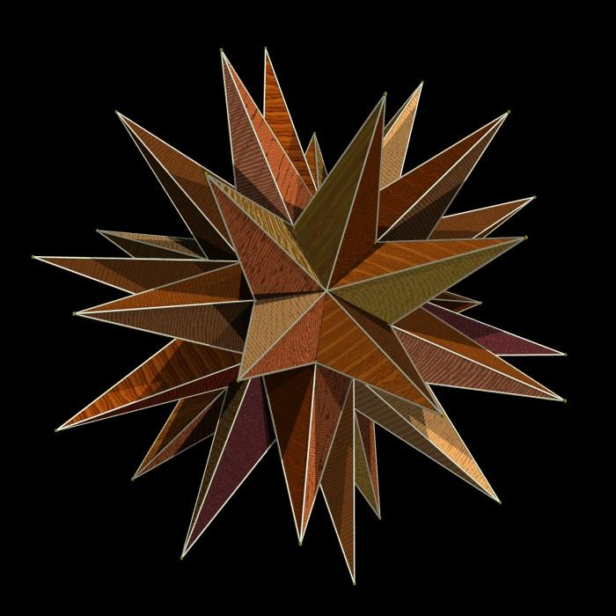
The solid consists of:
- 60 Antiparallelogram Faces: Crossed quadrilateral faces with pairs of opposite sides parallel.
- 120 Edges: Divided into 60 shorter edges and 60 longer edges.
- 42 Vertices: Forming the intersecting structure of the star polyhedron.
The faces intersect one another, and portions of the faces pass through the interior of the solid.

Face Composition
# Source: AI Source: Provided by: [Data Path: Persons Table -> ID Column: 1, Name_En Column: Motasem Essam] -> From: [ChatGPT] on [7/25/2026]
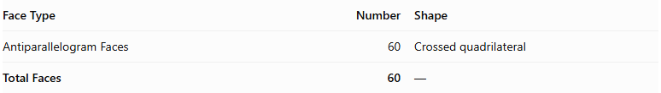
Face Type | Number | Shape
Antiparallelogram Faces | 60 | Crossed quadrilateral
Total Faces | 60 | —
Each antiparallelogram has:
- Two shorter edges of equal length.
- Two longer edges of equal length.
- Two pairs of opposite parallel sides.
- Self-intersecting diagonal geometry.
- A crossed, bow-tie-like appearance.

Mathematical Properties
# Source: AI Source: Provided by: [Data Path: Persons Table -> ID Column: 1, Name_En Column: Motasem Essam] -> From: [ChatGPT] on [7/25/2026]
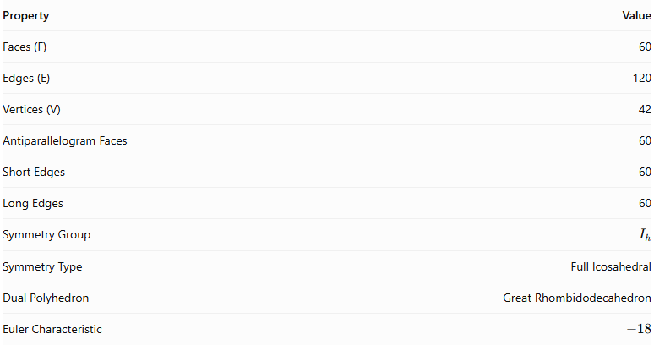
Property | Value
Faces (F) | 60
Edges (E) | 120
Vertices (V) | 42
Antiparallelogram Faces | 60
Short Edges | 60
Long Edges | 60
Symmetry Group | $$I_{h}$$
Symmetry Type | Full Icosahedral
Dual Polyhedron | Great Rhombidodecahedron
Euler Characteristic | $$-18$$
Euler Characteristic:
$$chi=V-E+F$$
$$chi=42-120+60=-18$$
Unlike a convex polyhedron, its Euler characteristic is not 2 because of its self-intersecting star-polyhedron structure.

Geometric Characteristics
# Source: AI Source: Provided by: [Data Path: Persons Table -> ID Column: 1, Name_En Column: Motasem Essam] -> From: [ChatGPT] on [7/25/2026]
- It is a nonconvex isohedral star polyhedron.
- All 60 faces are congruent antiparallelograms.
- Its faces are self-intersecting quadrilaterals.
- It has two distinct edge lengths.
- Its symmetry group is $I_{h}$, representing full icosahedral symmetry.
- Its Euler characteristic is $-18$.
- It is the dual of the Great Rhombidodecahedron.
- It is visually identical to the Great Deltoidal Hexecontahedron, although the names describe different aspects of its geometric construction.

Geometric Construction
# Source: AI Source: Provided by: [Data Path: Persons Table -> ID Column: 1, Name_En Column: Motasem Essam] -> From: [ChatGPT] on [7/25/2026]
The Great Rhombidodecacron is constructed as the dual of the Great Rhombidodecahedron.
- Begin with the Great Rhombidodecahedron.
- Locate the centers of its faces.
- Use these face centers as vertices of the dual.
- Connect the face centers according to the adjacency of the original faces.
- Construct one antiparallelogram face for each vertex of the original polyhedron.
- Complete the structure to obtain 60 intersecting antiparallelogram faces.
The original solid has 42 faces, 120 edges, and 60 vertices. Its dual has 60 faces, 120 edges, and 42 vertices.

Related Geometric Solids
# Source: AI Source: Provided by: [Data Path: Persons Table -> ID Column: 1, Name_En Column: Motasem Essam] -> From: [ChatGPT] on [7/25/2026]
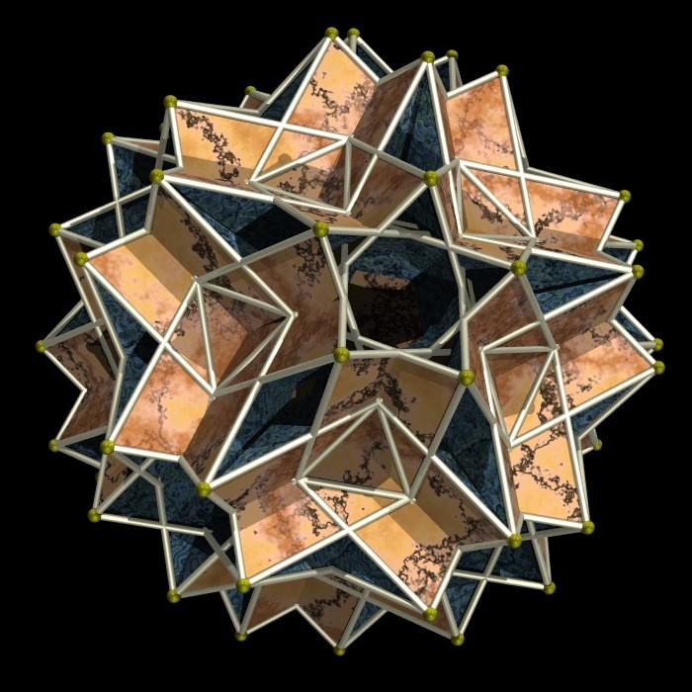
Great Rhombidodecahedron
The nonconvex uniform polyhedron whose dual is the Great Rhombidodecacron.
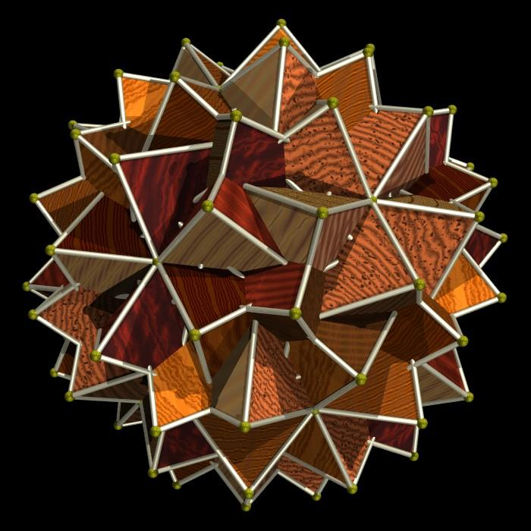
Great Deltoidal Hexecontahedron
A visually identical polyhedron with the same intersecting antiparallelogram face structure.
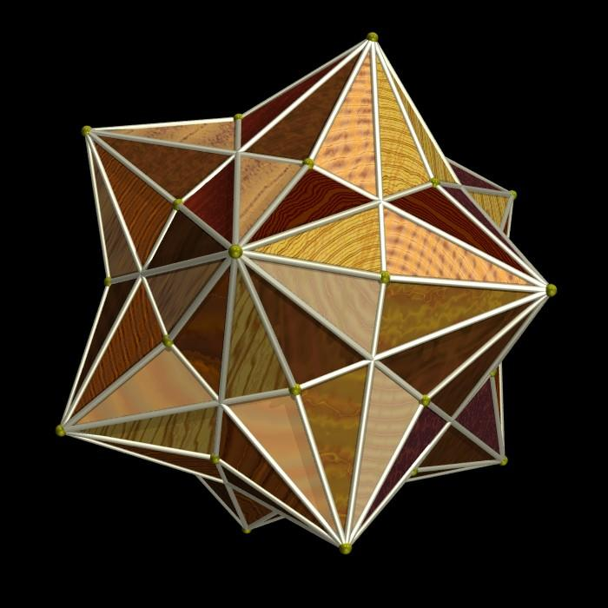
Small Rhombidodecacron
A related star polyhedron that is the dual of the Small Rhombidodecahedron. It also has 60 antiparallelogram faces but has different face proportions.

Key Points
# Source: AI Source: Provided by: [Data Path: Persons Table -> ID Column: 1, Name_En Column: Motasem Essam] -> From: [ChatGPT] on [7/25/2026]
- The Great Rhombidodecacron is a nonconvex isohedral star polyhedron.
- It has 60 antiparallelogram faces.
- It has 120 edges and 42 vertices.
- Its faces are self-intersecting quadrilaterals.
- It has full icosahedral symmetry $I_{h}$.
- Its Euler characteristic is $-18$.
- Its dual is the Great Rhombidodecahedron.
- It is visually identical to the Great Deltoidal Hexecontahedron.
- It should not be confused with the Small Rhombidodecacron.

Main Classification
# Source: AI Source: Provided by: [Data Path: Persons Table -> ID Column: 1, Name_En Column: Motasem Essam] -> From: [ChatGPT] on [7/25/2026]
Solid Geometry
└── Types of Solids
└── Rhombidodecacron
├── Great Rhombidodecacron
│ ├── Antiparallelogram Faces
│ ├── Short Edges
│ ├── Long Edges
│ ├── Vertices
│ └── Geometric Properties
└── Small Rhombidodecacron

Conclusion
# Source: AI Source: Provided by: [Data Path: Persons Table -> ID Column: 1, Name_En Column: Motasem Essam] -> From: [ChatGPT] on [7/25/2026]
The Great Rhombidodecacron is a nonconvex star polyhedron characterized by 60 intersecting antiparallelogram faces, 120 edges, and 42 vertices. Its dual relationship with the Great Rhombidodecahedron and its relationship to the Great Deltoidal Hexecontahedron make it an important example of dual star polyhedra.
Classification note: There are two distinct forms, the Great and Small Rhombidodecacron. The topic above describes the Great form.

